Package modul6_07014

Modul6_07014 Class::

package modul6_07014;

import modul6_07014.view.MainView;

/**

*

* @author Erye

*/

public class Modul6_07014 {

/**

* @param args the command line arguments

*/

public static void main(String[] args) {

MainView mainView = new MainView();

}

}

Keterangan Source Code :

------------------------------------------------------------------------------------------------------------------------------------------------------------------------------------------------------------------------------------------------------------------------------------------------------------------------------------------------------------------------------------------------------------------------------------------------------------------------------------------------------------------------------------------------------------------------------------------------------------------------------------------------------------------------------------------------------------------------------------------------------------------------------------------------------------------------------------------------------------------------------------------------------------------------------------------------------------------------------------------------------------------------------------------------------------------------------------------------------------------------------------------------------------------------------------------------------------------------------------------------------------------------------------------------------------------------------------------------------------------------------------------------------------------------------------------

Package modul6_07014.data

Data Class:

package modul6_07014.data;

import java.util.ArrayList;

import modul6_07014.model.Coffe;

/**

*

* @author Erye

*/

public class Data {

public static ArrayList<Coffe> coffeArr = new ArrayList<>();

}

Keterangan Source Code :

------------------------------------------------------------------------------------------------------------------------------------------------------------------------------------------------------------------------------------------------------------------------------------------------------------------------------------------------------------------------------------------------------------------------------------------------------------------------------------------------------------------------------------------------------------------------------------------------------------------------------------------------------------------------------------------------------------------------------------------------------------------------------------------------------------------------------------------------------------------------------------------------------------------------------------------------------------------------------------------------------------------------------------------------------------------------------------------------------------------------------------------------------------------------------------------------------------------------------------------------------------------------------------------------------------------------------------------------------------------------------------------------------------------------------------------

---------------------------------------------------------------------------------------------------------------------------------------------------------------------------------------------------------------------------------------------------------------------------------------------------------

Package modul6_07014.model

Coffee Class :

package modul6_07014.model;

public class Coffe {

private int id;

private String name;

private float price;

private int stock;

public Coffe(int id, String name, float price, int stock) {

this.id = id;

this.name = name;

this.price = price;

this.stock = stock;

}

public int getId() {

return id;

}

public void setId(int id) {

this.id = id;

}

Public String getName() {

return name;

}

public void setName(String name) {

this.name = name;

}

public float getPrice() {

return price;

}

public void setPrice(float price) {

this.price = price;

}

public int getStock() {

return stock;

}

public void setStock(int stock) {

this.stock = stock;

}

}

Keterangan Source Code :

------------------------------------------------------------------------------------------------------------------------------------------------------------------------------------------------------------------------------------------------------------------------------------------------------------------------------------------------------------------------------------------------------------------------------------------------------------------------------------------------------------------------------------------------------------------------------------------------------------------------------------------------------------------------------------------------------------------------------------------------------------------------------------------------------------------------------------------------------------------------------------------------------------------------------------------------------------------------------------------------------------------------------------------------------------------------------------------------------------------------------------------------------------------------------------------------------------------------------------------------------------------------------------------------------------------------------------------------------------------------------------------------------------------------------------------

------------------------------------------------------------------------------------------------------------------------------------------------------------------------------------------------------------------------------------------------------------------------------------------------------------------------------------------------------------------------------------------------------------------------------------------------------------------------------------------------------------------------------------------------------------------------------------------------------------------------------------------------------------------------------------------------------------------------------------------------------------------------------------------------------------------------------------------------------------------------------------------------------------------------------------------------------------------------------------------------------------------------------------------------------------------------------------------------------------------------------------------------------------------------------------------------------------------------------------------------------------------------------------------------------------------------------------------------------------------------------------------------------------------------------------------

---------------------------------------------------------------------------------------------------------------------------------------------------------------------------------------------------------------------------------------------------------------------------------------------------------

Package modul6_07014.view

AddProduct Class :

package modul6_07014.view;

import java.awt.Color;

import java.awt.Font;

import java.awt.event.ActionEvent;

import java.awt.event.ActionListener;

import javax.swing.JFrame;

import modul6_07014.data.Data;

import modul6_07014.model.Coffe;

import static modul6_07014.view.KomponenView.font;

/**

*

* @author Erye

*/

public class AddProduct extends KomponenView {

public AddProduct() {

jlProductId.setBounds(10, 25, 100, 18);

jlProductId.setFont(new Font(font, Font.BOLD, 14));

jlProductId.setForeground(Color.black);

add(jlProductId);

jtfProductId.setBounds(10, 40, 170, 21);

add(jtfProductId);

jlProductNm.setBounds(10, 65, 120, 18);

jlProductNm.setFont(new Font(font, Font.BOLD, 14));

jlProductNm.setForeground(Color.black);

add(jlProductNm);

jtfProductNm.setBounds(10, 85, 170, 21);

add(jtfProductNm);

jlPrice.setBounds(10, 105, 120, 18);

jlPrice.setForeground(Color.black);

jlPrice.setFont(new Font(font, Font.BOLD, 14));

add(jlPrice);

jtfPrice.setBounds(10, 125, 170, 21);

add(jtfPrice);

jlStock.setBounds(230, 25, 120, 18);

jlStock.setFont(new Font(font, Font.BOLD, 14));

jlStock.setForeground(Color.black);

add(jlStock);

jtfStock.setBounds(230, 40, 170, 21);

add(jtfStock);

jbBack.setBounds(20, 200, 100, 21);

add(jbBack);

jbBack.addActionListener(new ActionListener() {

@Override

public void actionPerformed(ActionEvent e) {

MainView main = new MainView();

dispose();

setLocationRelativeTo(null);

main.setVisible(true);

}

});

jbAdd.setBounds(240, 200, 150, 25);

jbAdd.setFont(new Font(font, Font.BOLD, 10));

add(jbAdd);

jbAdd.addActionListener(new ActionListener() {

@Override

public void actionPerformed(ActionEvent e) {

String nama = jtfProductNm.getText();

int id = Integer.parseInt(jtfProductId.getText());

float price = Float.parseFloat(jtfPrice.getText());

int stok = Integer.parseInt(jtfStock.getText());

Coffe coffe = new Coffe(id, nama, price, stok);

Data.coffeArr.add(coffe);

setVisible(false);

MainView mainView = new MainView();

}

});

setTitle("Erye");

setLayout(null);

setSize(450, 300);

setLocationRelativeTo(null);

setDefaultCloseOperation(JFrame.EXIT_ON_CLOSE);

setVisible(true);

}

}

Keterangan Source Code :

------------------------------------------------------------------------------------------------------------------------------------------------------------------------------------------------------------------------------------------------------------------------------------------------------------------------------------------------------------------------------------------------------------------------------------------------------------------------------------------------------------------------------------------------------------------------------------------------------------------------------------------------------------------------------------------------------------------------------------------------------------------------------------------------------------------------------------------------------------------------------------------------------------------------------------------------------------------------------------------------------------------------------------------------------------------------------------------------------------------------------------------------------------------------------------------------------------------------------------------------------------------------------------------------------------------------------------------------------------------------------------------------------------------------------------------

------------------------------------------------------------------------------------------------------------------------------------------------------------------------------------------------------------------------------------------------------------------------------------------------------------------------------------------------------------------------------------------------------------------------------------------------------------------------------------------------------------------------------------------------------------------------------------------------------------------------------------------------------------------------------------------------------------------------------------------------------------------------------------------------------------------------------------------------------------------------------------------------------------------------------------------------------------------------------------------------------------------------------------------------------------------------------------------------------------------------------------------------------------------------------------------------------------------------------------------------------------------------------------------------------------------------------------------------------------------------------------------------------------------------------------------

---------------------------------------------------------------------------------------------------------------------------------------------------------------------------------------------------------------------------------------------------------------------------------------------------------

KomponenView Class :

package modul6_07014.view;

import javax.swing.JButton;

import javax.swing.JFrame;

import javax.swing.JLabel;

import javax.swing.JPanel;

import javax.swing.JScrollPane;

import javax.swing.JTable;

import javax.swing.JTextField;

/**

*

* @author Erye

*/

public class KomponenView extends JFrame {

static String font = "Consolas";

JTable coffee = new JTable();

JLabel judul = new JLabel("Coffee Shop Cashier");

JTextField jtfProductId = new JTextField();

JTextField jtfProductNm = new JTextField();

JTextField jtfPrice = new JTextField();

JTextField jtfStock = new JTextField();

JTextField jtfQuantity = new JTextField();

JTextField jtfTotal = new JTextField();

JLabel jlProductId = new JLabel("Product ID");

JLabel jlProductNm = new JLabel("Product Name");

JLabel jlPrice = new JLabel("Price");

JLabel jlQuantity = new JLabel("Quantity");

JLabel jlStock = new JLabel("Stock");

JLabel jlTotal = new JLabel("Total Sales");

JButton jbClear = new JButton("!Clear Field");

JButton jbPrint = new JButton("Print Struct");

JButton jbAdd = new JButton("+ Add Product");

JPanel color = new JPanel();

JScrollPane scrool = new JScrollPane(coffee);

JButton jbBack = new JButton("Back");

}

MainView Class :

default:

jpLayout.setBackground(Color.red);

break;

}

}

});

jrIndoToIng.setBounds(18, 60, 200, 26);

jrIndoToIng.setBackground(new Color(0, 0, 0, 0));

add(jrIndoToIng);

jrIndoToIng.setSelected(true);

jrIngToIndo.setBounds(250, 60, 250, 26);

jrIngToIndo.setBackground(new Color(0, 0, 0, 0));

add(jrIngToIndo);

buttonGroup.add(jrIndoToIng);

buttonGroup.add(jrIngToIndo);

lblKata.setBounds(24, 100, 100, 26);

add(lblKata);

jtxtKata.setBounds(100, 100, 375, 26);

add(jtxtKata);

jtxtKata.addActionListener(new ActionListener() {

@Override

public void actionPerformed(ActionEvent e) {

if (jrIngToIndo.isSelected() == false && jrIndoToIng.isSelected() == false) {

JOptionPane.showMessageDialog(null, "Pilih Translate terlebih dahulu !");

} else {

if (jtxtKata.getText().equals("")) {

JOptionPane.showMessageDialog(null, "Kata belum diinputkan !");

} else {

int status = jrIngToIndo.isSelected() == true ? 1 : 2;

String kata = kamusController.searchWord(jtxtKata.getText(), status);

if (kata == null) {

JOptionPane.showMessageDialog(null, "Kata tidak ditemukan !");

} else {

System.out.println("KATA = " + kata);

jtxtDetail.setText(kata);

}

}

}

}

});

jtxtDetail.setBounds(24, 140, 450, 100);

add(jtxtDetail);

jpLayout.setBounds(12, 56, 475, 375);

jpLayout.setBackground(Color.red);

add(jpLayout);

setTitle("Kamus");

setSize(500, 500);

setLayout(null);

setLocationRelativeTo(null);

setDefaultCloseOperation(JFrame.EXIT_ON_CLOSE);

setVisible(true);

}

}

Keterangan Source Code :

---------------------------------------------------------------------------------------------------------------------------------------------------------------------------------------------------------------------------------------------------------------------------------------------------------------------------------------------------------------------------------------------------------------------------------------------------------------------------------------------------------------------------------------------------------------------------------------------------------------------------------------------------------------------------------------------------------------------------------------------------------------------------------------------------------------------------------------------------------------------------------------------------------------------------------------------------------------------------------------------------------------------------------------------------------------------------------------------------------------------------------------------------------------------------------------------------------------------------------------------------------------------------------------------------------------------------------------------------------------------------------------------------------------------------------------------------------------------------------------------------------------------------------------------

---------------------------------------------------------------------------------------------------------------------------------------------------------------------------------------------------------------------------------------------------------------------------------------------------------------------------------------------------------------------------------------------------------------------------------------------------------------------------------------------------------------------------------------------------------------------------------------------------------------------------------------------------------------------------------------------------------------------------------------------------------------------------------------------------------------------------------------------------------------------------------------------------------------------------------------------------------------------------------------------------------------------------------------------------------------------------------------------------------------------------------------------------------------------------------------------------------------------------------------------------------------------------------------------------------------------------------------------------------------------------------------------------------------------------------------------------------------------------------------------------------------------------------------------

---------------------------------------------------------------------------------------------------

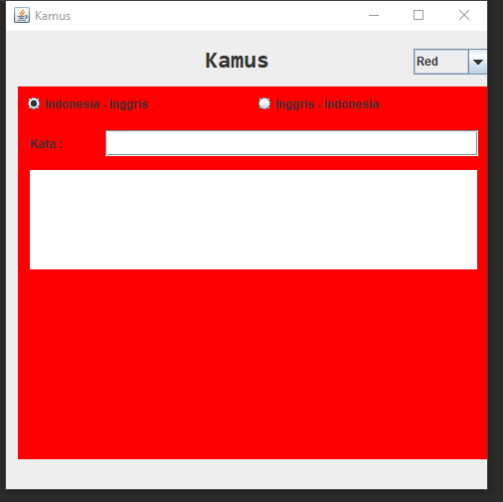

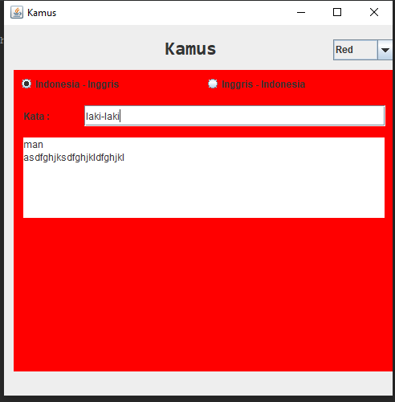

Keterangan Source Code :

---------------------------------------------------------------------------------------------------------------------------------------------------------------------------------------------------------------------------------------------------------------------------------------------------------------------------------------------------------------------------------------------------------------------------------------------------------------------------------------------------------------------------------------------------------------------------------------------------------------------------------------------------------------------------------------------------------------------------------------------------------------------------------------------------------------------------------------------------------------------------------------------------------------------------------------------------------------------------------------------------------------------------------------------------------------------------------------------------------------------------------------------------------------------------------------------------------------------------------------------------------------------------------------------------------------------------------------------------------------------------------------------------------------------------------------------------------------------------------------------------------------------------------------------

---------------------------------------------------------------------------------------------------------------------------------------------------------------------------------------------------------------------------------------------------------------------------------------------------------------------------------------------------------------------------------------------------------------------------------------------------------------------------------------------------------------------------------------------------------------------------------------------------------------------------------------------------------------------------------------------------------------------------------------------------------------------------------------------------------------------------------------------------------------------------------------------------------------------------------------------------------------------------------------------------------------------------------------------------------------------------------------------------------------------------------------------------------------------------------------------------------------------------------------------------------------------------------------------------------------------------------------------------------------------------------------------------------------------------------------------------------------------------------------------------------------------------------------------

---------------------------------------------------------------------------------------------------